# **OPTIMISING TIME-LIMITED NON-PHARMACEUTICAL INTERVENTIONS FOR COVID-19 EPIDEMIC CONTROL**

**RESULTS**

Five different strategies were considered to explore the impact of differing lockdown measures on the trajectory of a COVID-19 epidemic curve (**Figure 1**). Each of these differ with regard to the “shape” of *c(t)* and subsequent *β(t)* reductions over the explored intervention duration. Exact mathematical formulation of each scenario can be found in the ***Methods*** section.

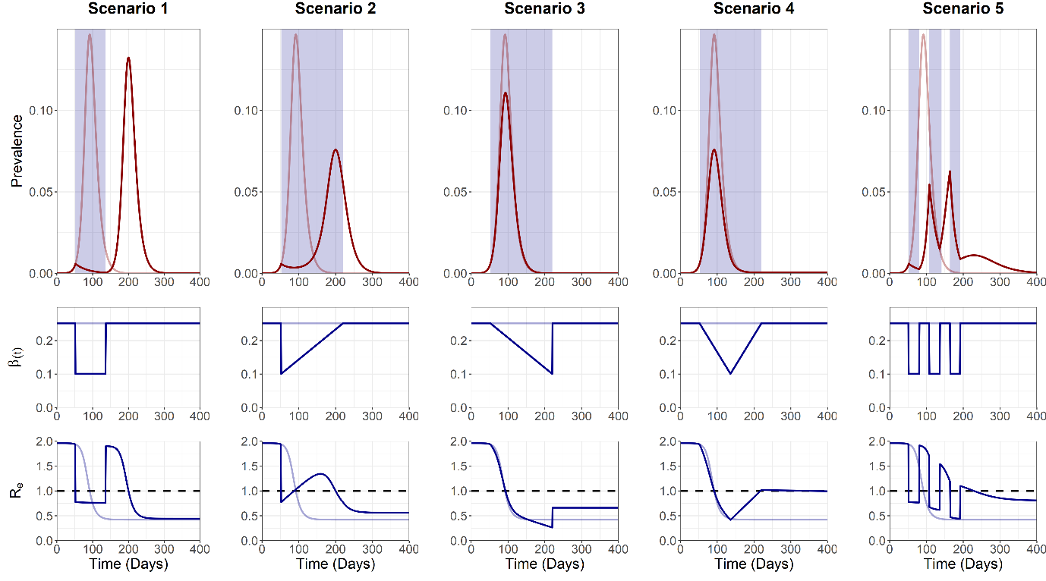

**Figure 1. Trajectory plots for the epidemic curve, intervention associated *β(t)* reductions and *Re*, for the five intervention scenarios**. Partially visible red and blue lines denote unmitigated epidemic curve dynamics.Blue shading on the trajectory plot indicates the duration of the intervention. Dotted black line on the *Re* plot denotes the threshold for sustained epidemic growth.

Using baseline parameters, the maximum *I(t)* peak, *Imax*, was observed at 0.146 (*t* = 92), 0.132 (*t* = 200), 0.076 (*t* = 200) and 0.111 (*t* = 93), 0.076 (*t* = 92) and 0.063 (*t* = 164), and a total cumulative incidence, *Ic(∞)*, of 0.786, 0.775, 0.7134, 0.663, 0.493 and 0.587 for an unmitigated epidemic and intervention 1, 2, 3, 4 and 5 respectively. Scenario 1 and 2 resulted in the suppression of the epidemic following the initiation of lockdown measures, with a resurgent 2nd peak occurring after the cessation of the intervention, with Re > 1. Consistent with basic epidemic theory, this can largely be attributed to the large pool of remaining susceptibles following the cessation of the intervention, due to strong initial lockdown measures. A mitigated initial epidemic peak was observed for scenario 3 and 4 due to the effects of population immunity and gradual “ramping up” of *β(t)* reductions, suppressing *Re* < 1 and preventing a secondary epidemic peak occurring. The pulsed nature of scenario 5 allowed for brief opportunities for the build-up of population immunity (*Re* > 1) and subsequent epidemic control (*Re* < 1).

**Analysis 2**

A sensitivity analysis was next conducted to observe the sensitivity of each scenario to two outcome measures: 1) The maximum *I(t)* peak, *Imax*, and 2) the total cumulative incidence, *Ic(∞)*. These outcome measures were explored in relation to three model parameters: 1) Intervention trigger day (*tp*), 2) lockdown-related scaling factor magnitude (*cmin*) and 3) The intervention duration (*dt*). Each sensitivity analysis was conducted with all other parameters held at baseline levels (**Figure 2**).

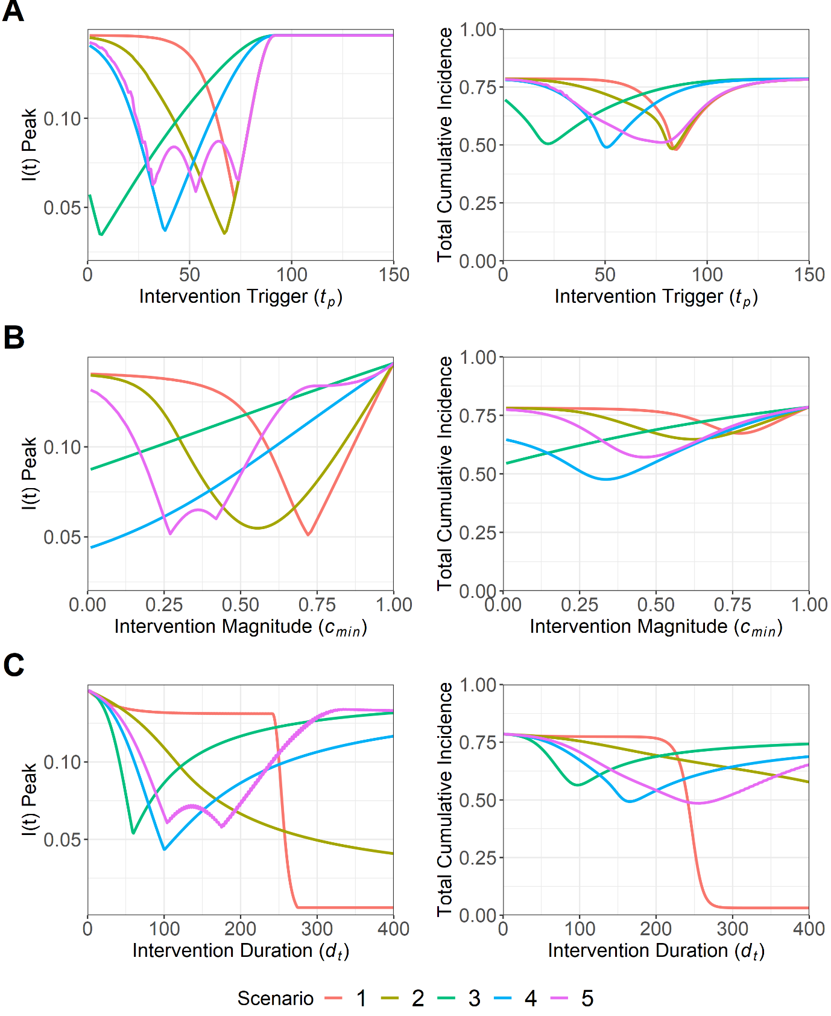

**Figure 2. Sensitivity analysis for *I(t)* peak, *Imax*, and total cumulative incidence, *Ic(∞)*, for the five intervention scenarios. This was conducted for the following model parameters: A) Intervention trigger day (*tp*), B) Minimum value of lockdown-related scaling factor *c(t)* (*cmin*) and C) Intervention duration (*dt*)**. Note that for A) and B) scenarios are comparable for a specific explored parameter value, with the duration of scenario 2, 3, 4 and 5 being doubled to ensure similar intervention magnitudes across all scenarios. This was not possible for C) as *dt* remains fixed across all scenarios.

A narrow optimal *tp* parameter space to minimise *Imax* for was observed for scenarios 1 (*t* = 72), 2 (*t* = 67), 3 (*t* = 7) and 4 (*t* = 38) and 5 (32 < *t* < 74) (**Figure 2A)**. Suboptimal deviations from the *tp* optimum rapidly increased *Imax* for scenario 1, 2 and 4, with a similar gradient either side of the optimum suggesting that intervening too late/early makes little difference. Scenario 3 and 5 were exceptions, with an early intervention being more beneficial to minimise *Imax* and *Ic(∞)* for scenario 3, and a large range of optimal *tp* values being observed for scenario 5. Optimal *tp* values were larger for *Ic(∞)* relative to *Imax*, with a greater freedom to choose suboptimal *tp* values for all scenarios, while still preventing large increases in *Ic(∞)*.

Lower values of the lockdown-related scaling factor magnitude, *cmin*, were found to be optimal for scenario 3 and 4 to minimise *Imax* and *Ic(∞)* **(Figure 2B)**. Intermediate *cmin* values were found to be optimal for scenario 1, 2 and 5, with the scenario 2 *Imax* being less sensitive to suboptimal alterations from the optimum *cmin* value. Lower suboptimal *cmin* values for scenario 1, 2 and 5 were shown to be more beneficial than *cmin* values which were too high, suggesting that it is more beneficial to intervene too strongly, than insufficiently.

Larger *dt* values were found to be optimal to reduce *Imax* and *Ic(∞)* for scenario 1 and 2 (**Figure 2C**). We note that despite the optimums identified in scenario 3 (*t* = 60), 4 (*t* = 102) and 5 (104 < *t* < 175), if a suboptimal *dt* value is chosen, it is more beneficial to intervene for too long and increase *dt*, than to intervene insufficiently if the primary aim is to minimise *Imax* and *Ic(∞)*.

**Analysis 3**

A sensitivity analysis was next conducted to identify the optimal parameter space to minimise *Imax* and *Ic(∞)* for a multi-dimensional parameter space: 1) Intervention trigger day (*tp*) and 2) Intervention duration (*dt*) (**Figure 3**).

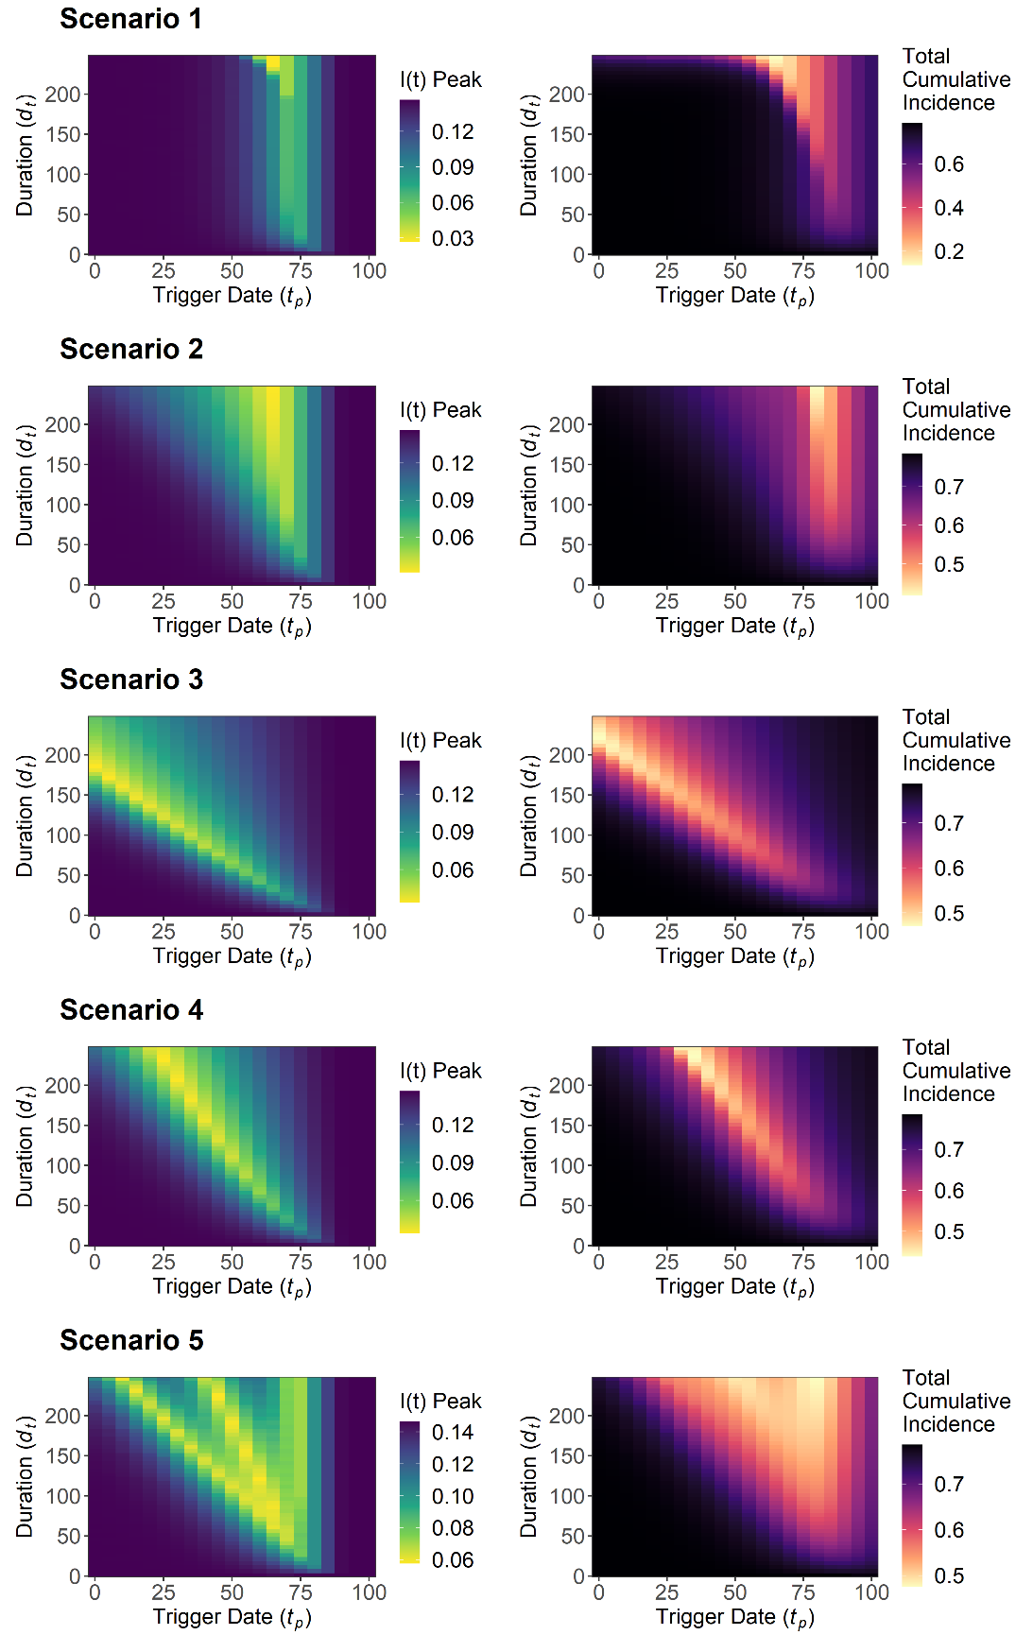

**Figure 3. Sensitivity analysis for *I(t)* peak, *Imax*, and total cumulative incidence, *Ic(∞)*, for intervention trigger day, *tp*, and the intervention duration, *dt*. This was explored for the five intervention scenarios.** Note that for a specific value of *dt*, scenario 1 is not comparable with scenario 2, 3, 4 and 5. This relates to the need to double *dt* for the latter scenarios to ensure a comparable intervention magnitude over the intervention duration for baseline analysis, which is not possible for this sensitivity analysis with *dt* being an explored parameter. **– so legends are all different**

Varying *dt* has minimal impact on reducing *Imax* for the given optimal value of *tp* in scenario 1 (*tp* = 65) and 2 (*tp* = 65), until a sufficiently large value of *dt* (*dt* > 200), where we observe the existence of an optimal parameter space to minimise *Imax* and *Ic(∞)*. A different qualitative pattern was observed in scenario 3 and 4, with decreases in *dt* required to maintain the optimal parameter space as *tp* is increased. Rough qualitative agreement was found between the overall optimal parameter space for both outcome measures across all scenarios.

Suboptimal values of *tp* were found to be less detrimental as *dt* was increased for scenario 2, 3, 4 and 5, with *Imax* and *Ic(∞)* being less sensitive to alterations from the *tp* optimum. This suggests the benefits of increasing the length of an intervention to compensate for a suboptimal intervention trigger point. However, there is a caveat with scenario 5, due to the presence of suboptimal *tp* parameter “gaps”, with the size of these gaps also widening as *dt* increases. This is less pronounced for *Ic(∞)* compared to *Imax*.

The sensitivity analysis was repeated with *cmin* = 0.25/0.5/0.75 to assess the sensitivity of the system to a third parameter (**Figure S2 + 3**) . Lower *cmin* values of 0.25 (scenario 1, 2 and 3) and 0.5 (scenario 3 and 4) were found to be more optimal to minimise *Imax* for a given *tp*/*dt* parameter combination. The lowest explored value of *cmin* was found to be optimal to minimise *Ic(∞)* for all scenarios. We also note that while *cmin* = 0.75 and consequently weaker lockdown measures were associated with lower possible *Imax* and *Ic(∞)* values, the outcome measures became less sensitive to suboptimal parameter choices.

**Analysis 4**

Two sequentially implemented lockdown measures were introduced for each of the five scenarios to explore the impact of multiple interventions on the trajectory curve of the simulated COVID-19 epidemic. The lockdown-related scaling factor was kept static at baseline for both interventions *cmin1* = *cmin2* = 0.4. Baseline duration for intervention 1 and 2 was set at *dt1* = *dt2* = 42 days (6 weeks) for scenario 1, and *dt1* = *dt2* = 84 days (12 weeks) for scenario 2, 3, 4 and 5. The intervention trigger point was set at *tp1* = *tp2* = 42 days for both interventions, with *dt2* being defined relative to the end of intervention 1 (**Figure 4**).

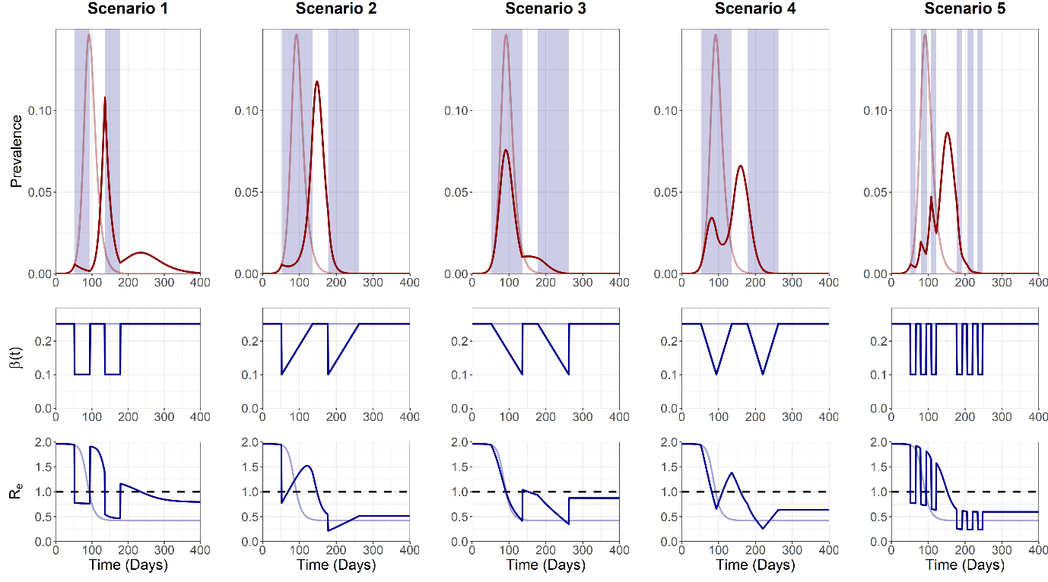

**Figure 4. Trajectory plots for the epidemic curve, intervention associated R0 reductions and Re, for the five “double” intervention scenarios.** Partially visible red and blue lines denote unmitigated epidemic curve dynamics.Blue shading on the trajectory plot indicates the duration of the two interventions. Dotted black line on the Re plot denotes the threshold for sustained epidemic growth. **EXPLAIN THE DIFFERING INTERVENTION LENGTH**

Maximum peak I(t), *Imax*, was observed at 0.107 (*t* = 136), 0.118 (*t* = 148), 0.076 (*t* = 92), 0.066 (*t* = 159) and 0.086 (*t* = 152) and a total cumulative incidence, *Ic(∞)*, of 0.594, 0.738, 0.555, 0.675 and 0.696 for intervention 1, 2, 3, 4 and 5 respectively. We note the occurrence of a large second epidemic peak in scenario 1 and 2, with *Re* increasing substantially above 1 between interventions. A third epidemic peak was also observed due to the strong *β(t)* lockdown measures imposed by scenario 1, with *Re* > 1 occurring transiently after the cessation of the second intervention.

**Analysis 5**

A sensitivity analysis was next conducted with the multiple intervention model to explore the optimal parameter space to minimise *Imax* and *Ic(∞)* for two parameters: 1) Intervention 1 trigger date, *tp1*, and 2) Intervention 2 trigger date, *tp2* (**Figure 5**).

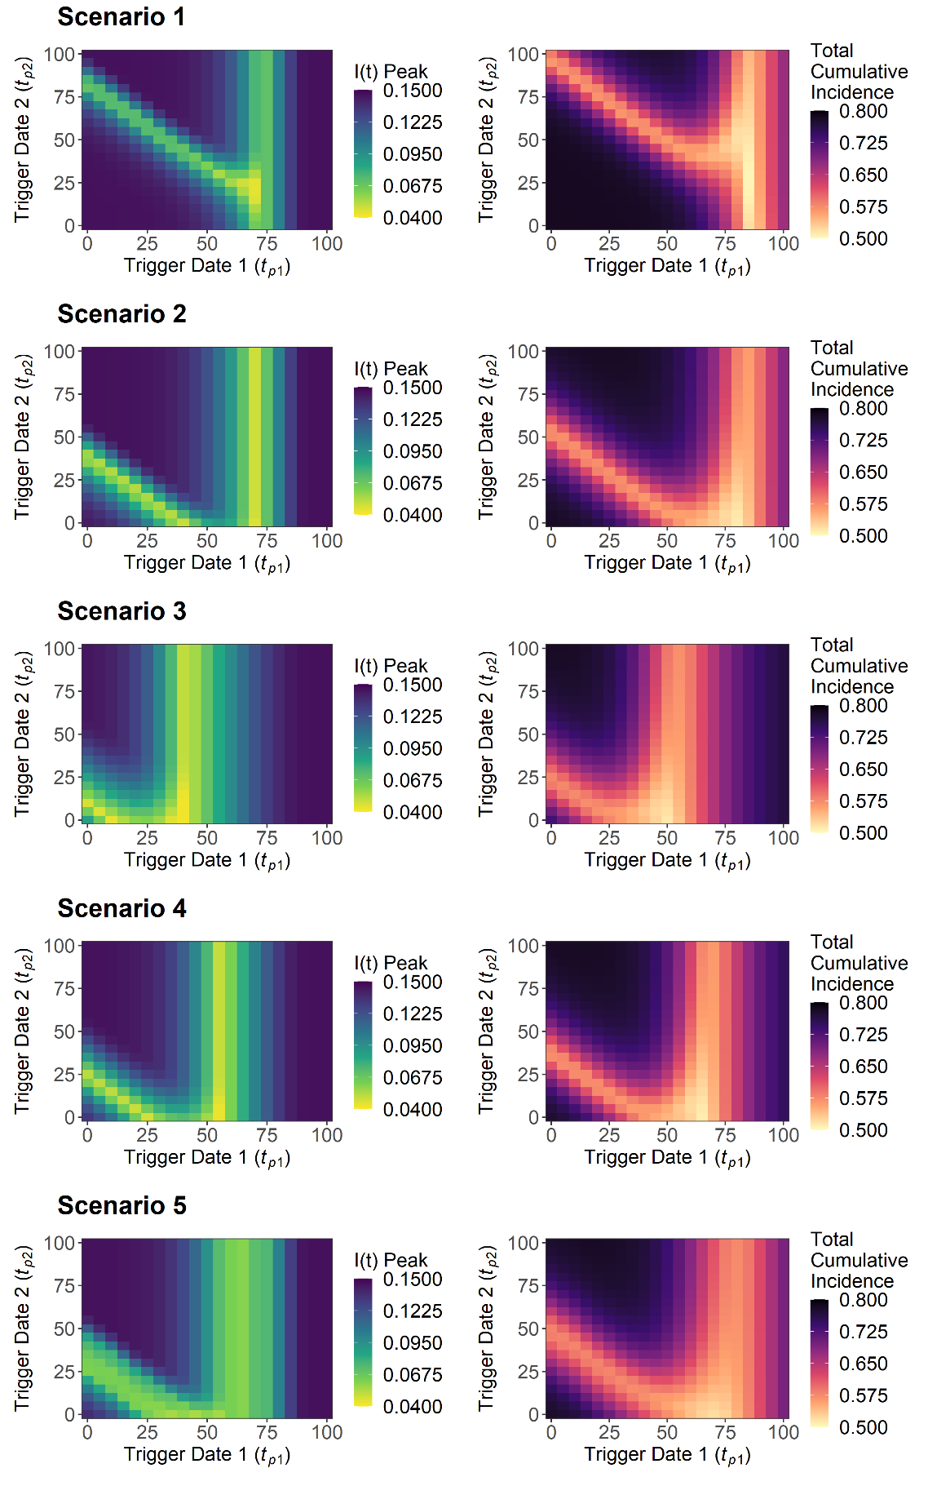

**Figure 5. Sensitivity analysis for I(t) peak and total cumulative incidence for intervention 1 trigger date and intervention 2 trigger date. This was explored for the five intervention scenarios.** To ensure comparable overall magnitude of interventions of over the intervention duration, the intervention duration of Scenarios 2, 3, 4 and 5 were doubled relative to scenario 1 (12 vs 6 weeks). All scenarios are therefore comparable for a given parameter value combination – **so legends are the same**

An intermediate value of *tp1* was found to be optimal to minimise *Imax* and *Ic(∞)* for all scenarios, with an early introduction of intervention 2, and low value of *tp2*, being the most optimal. Scenario 1 was found to possess subtly different dynamics, with an intermediate *tp2* value being more optimal. We note that on the condition that the optimal value of *tp1* value is achieved, a large range of *tp2* values can still effectively minimise *Imax* and *Ic(∞)*, suggesting that optimising the timing of intervention 1 is more critical than for intervention 2. Agreement was found between the optimal *tp1*/*tp2* parameter space to minimise both outcome measures for all scenarios.

The sensitivity analysis was expanded for two additional parameters: 1) Intervention 1 duration (*dt1*) and Intervention 2 duration (*dt2*) (**Figure S5-14**). Increasing *dt1* shifted the optimal *tp2* value for *Imax* and *Ic(∞)* upwards marginally for scenario 1, with negligible effect observed for all other scenarios. Altering *dt2* had little effect on altering the optimal parameter space for all scenarios.

A sensitivity analysis was next conducted to explore the optimal parameter space for the lockdown related scaling factor for: 1) Intervention 1, *cmin1*, and 2) Intervention 2, *cmin2*, to minimise *Imax* and *Ic(∞)* outcome measures. The we explored the range 0 ≤ *cmin1* ≤ 1 and 0 ≤ *cmin2* ≤ 1 (**Figure 6**).

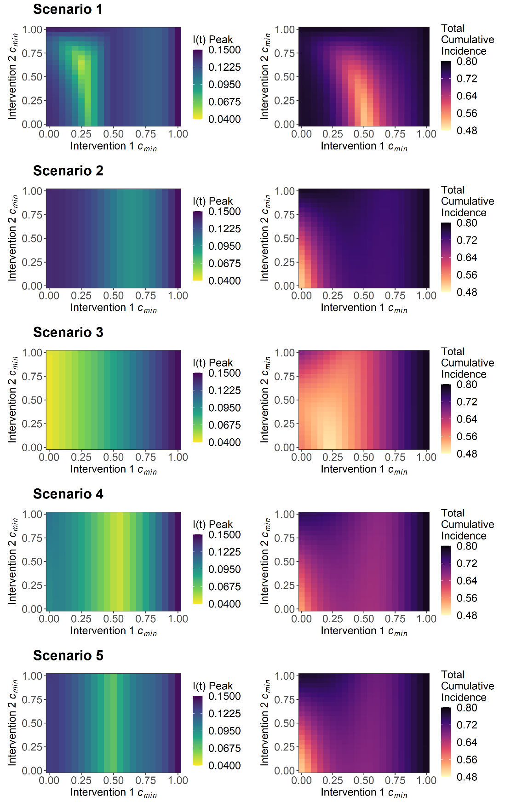

**Figure 6. Sensitivity analysis for I(t) peak and total cumulative incidence for the magnitude of the intervention 1 R0 reductions and intervention 2 R0 reductions. This was explored for the five intervention scenarios.** To ensure comparable overall magnitude of interventions of over the intervention duration, the intervention duration of Scenarios 2, 3, 4 and 5 were doubled relative to scenario 1 (12 vs 6 weeks). All scenarios are therefore comparable for a given parameter value combination. – **so legends are the same**

An intermediate optimal *cmin1* value was observed for scenario 2, 4 and 5 to minimise *Imax*. The optimal parameter space to minimise *Ic(∞)* differed for these scenarios, with low *cmin1* and *cmin2* values and a subsequently stronger set of interventions being more beneficial. This differed for scenario 1 and 3, with scenario 1 favouring an intermediate *cmin1* and a low *cmin2* value, and scenario 3 benefitting from a low *cmin1* and *cmin2* value, to minimise both outcome measures. This analysis was expanded for 1) Intervention 1 duration, *dt1*, and 2) Intervention 2 duration, *dt2*, with reductions in *Imax* and *Ic(∞)* being observed as *dt1* increased and alterations to *dt2* providing minimal changes to either outcome measure. The exception was scenario 3, with increases from baseline *dt1* resulting in detrimental increases to *Imax* and *Ic(∞)*.

Trajectory curves were obtained by varying combinations of both *cmin1*/*cmin2* across all scenarios to explore these counterintuitive results in more detail (**Figure S15-16**). We observe two key qualitative patterns that enable scenarios to minimise *Imax*: 1) Intervention peak timing and 2) Intervention *cmin* balance. Intervention scenarios which successfully reduce *Imax* were found to somewhat match the timing of the epidemic peaks with timing of the maximum reductions in β(t) due to the interventions (timing of *cmin1*/*cmin2*) (**Figure S**). Additionally, we identify a well known epidemiological phenomenon of balancing *cmin* to reduce epidemic peak height. This balanced *cmin* prevents both an unmitigated initial epidemic due to an insufficient intervention (**Figure S**) or a delayed epidemic following the cessation of an intervention which is too strong and which maintains a large pool of susceptibles (**Figure S**).